# Site description and methodology

## Site description

The experiment site is located in Griffin Forest, Perthshire (UK), on the north facing slope of the Tay Valley at about 4 km from the town of Aberfeldy.

Figures 1 shows the monthly average temperature for Aberfeldy. This area is characterised by relatively cool winters and warm summers, compared to Scotland. The average annual rainfall for the same period is about 1050 mm per year, with a maximum in 2014 (1376.2 mm) and a minimum in 2016 (768.6 mm).

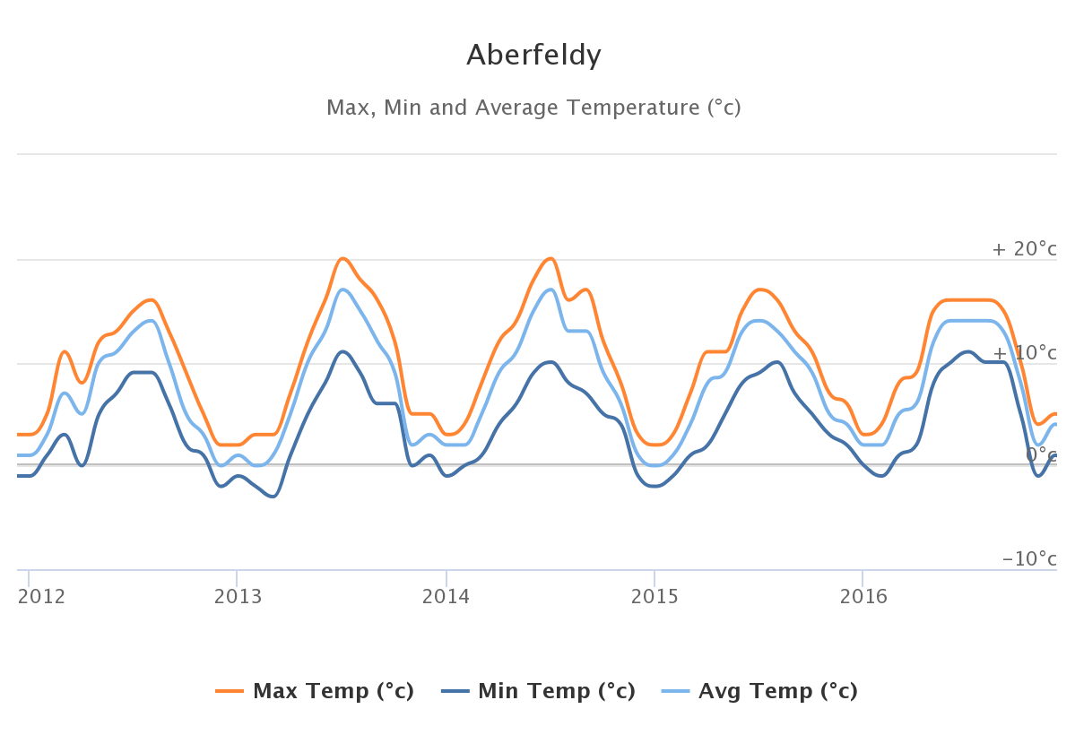

*Fig. 1: average monthly temperatures in Aberfeldy, years 2012-2016. Source: weatheronline.com*

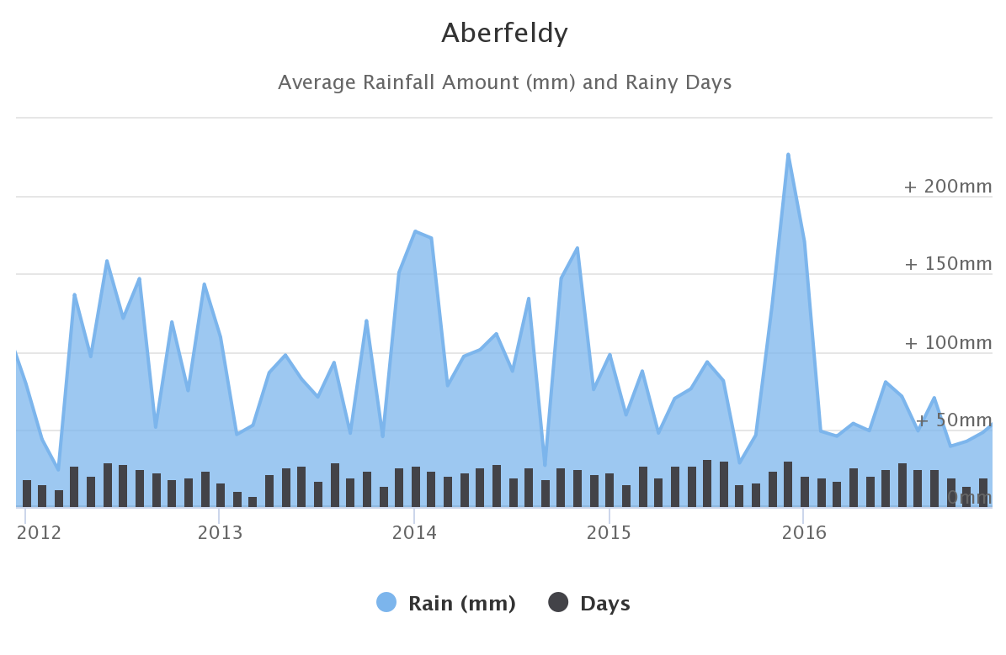

*Fig. 2: average monthly precipitation in Aberfeldy, years 2012-2016. Source: weatheronline.com*

Rocks in the area of Aberfeldy belong to the Dalradian supergroup, metamorphosed marine sediments of late-Precambrian and Lower Palaeozoic age (Craig 1925).

The bedrock under the forest is characterised by Psammite and Semipelite with minor inclusions of metalava and metatuff, covered by Devensian till deposits (see fig. 3 and 4).

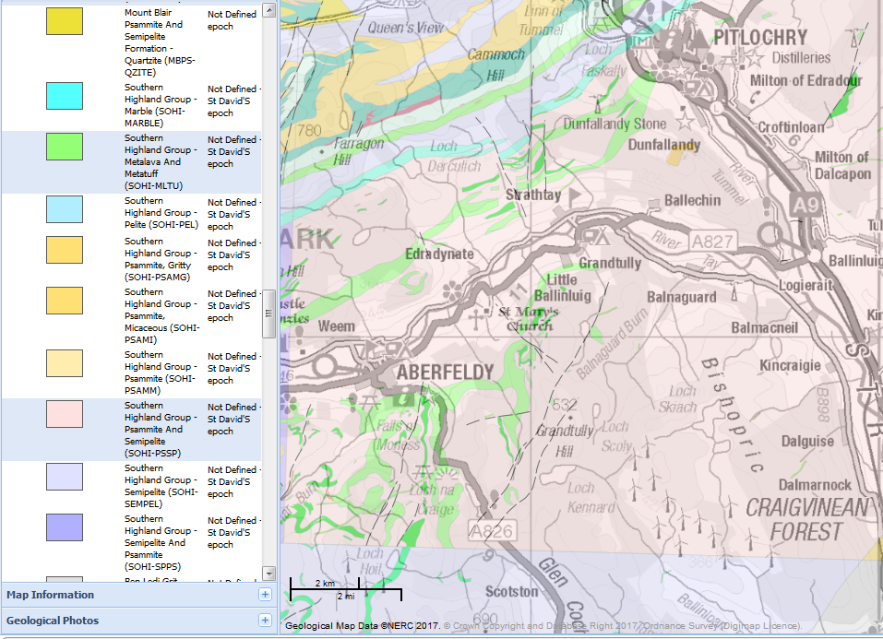

*Fig:3 geological map of the bedrock in the Griffin Forest area (1:50000). Source: Edina digimap.*

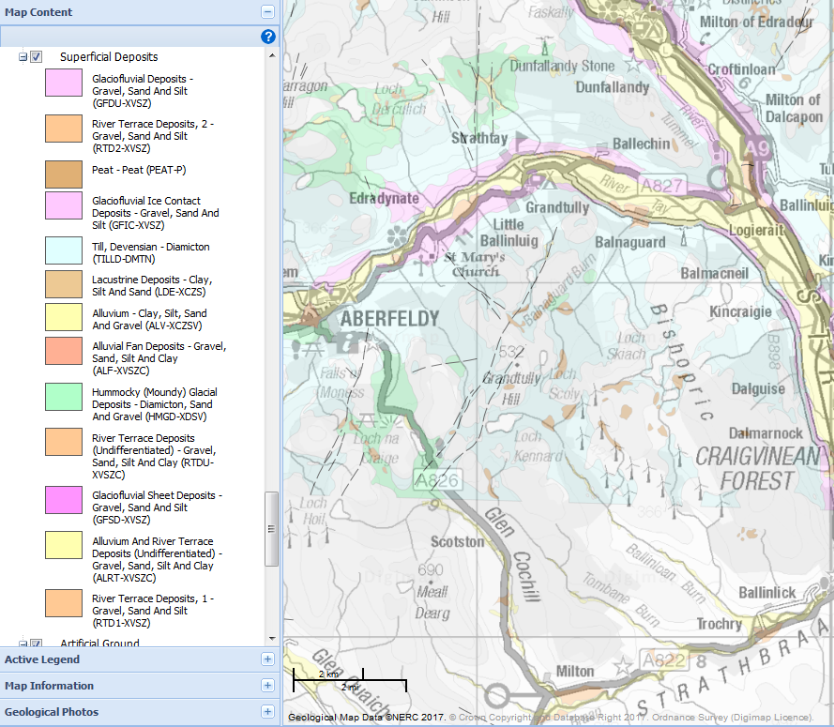

*Fig:3 geological map of the superficial deposits in Griffin Forest area (1:50000). Source: Edina digimap.*

### Before afforestation: brief history of forest cover in Scotland

“In the aftermaths of the last Ice Age some type of Forest covered the Highlands, apart from the high tops, though pine and oak did not grow on the islands and the flow country of the north, where such cover was largely consisted of birch and hazel. However, there is no evidence that even in Roman times, 2000 years ago, the forest was still anything like this extent. Whilst in north-west Scotland the pine forests were largely replaced by blanket-bog before any large impact by man, in the Eastern Highlands human activity was the main destructive agent, stretching over a period from about 1700 BC to about 1000 AD: the fire, the cattle, the sheep and the goats of the Highland peasants, aided by a period of climatic deterioration (the “Little Ice Age” started in the later fourteenth century and not really over before the late seventeenth century) reduced the estimated 50-60% of forest cover during the Mesolithic period to about the four percent during the Middle Ages.

Tompkins, Steve. Forestry in crisis. The battle for the hills. 1989. Christopher Helm, London.

“The vocabulary of an upland forester draws irresistible comparisons with agriculture. Afforestation of a bare hillside requires fencing, the elimination of wildlife such as hares and deer (regarded as vermin), deep ploughing and drainage, planting, fertilising and weeding. Today’s foresters talk of rotations, crops and harvests. Their crops have become steadily more dependend on a single, alien species, the Sitka spruce, with lodgepole pine used where the ground is poorest. Tree-breeding programmes are also ensuring that the genetic base of the plants used will steadily decrease. Blanket afforestation consists of even aged conifer monocultures, that are harvested and replanted, like any crop of surplus grain, except that the trees take decades to grow.

The first basic ingredient or recent British forestry policy has always been an obsession with a target area of bare land to be afforested. During the WWI about 182,000 ha of mostly broadleaved woodland were felled. The Forestry Act of 1919 formed the foundations of today’s forestry policy and practices. The Forestry Commission (FC) was created and a target of 0.75 million ha of new forests was set. The WWII came all too soon, and so the need for more timber. In 1943 the FC set a new ambitious target: 1.2 million ha to be afforested and a further 0.8 million ha of “effective” forest to be created by restocking existing woodlands. Afforestation continued undisturbed despite of the loss of strategic interest; the justification came to the creation and diversification of employment in rural areas. At the end of the 1970s the 1943 target was about to be passed. In December 1980 a ministerial statement announced a forestry policy that did not mention a total area of plantations anymore, but envisaged an afforestation rate of 20,000-25,000 ha per year, later increased to 30,000 ha in March 1986. Since 1919 upland afforestation has continued inexorably. Over the last 60 years nearly 18,000 ha have been planted each year.

The second basic ingredient of British forestry is that the rapid expansion of coniferous plantations has occurred on land where tree growth is least satisfactory – in the uplands. This was due to avoid competition with agriculture, as the production of food was seen to be of key importance, and to take place on cheap land and on a large scale, to reduce unit costs. As to 1986, 34% of hill, moor and rough grazing in Scotland had been afforested (source: NCC 1986).

The main factors determining the maximum height at which trees can grow are altitude, climate (especially wind exposure) and soil quality. The potential maximum height of the tree line exceeds only slightly the 600 meters in the Cairngorms which is sensible lower than what can be found in Northern America and Scandinavia at similar latitudes. This can be due to the combination of the cool and wet oceanic climate and the wind exposure; soil types also indirectly reflect these two factors, as a direct combination of relieves and rainfall pattern (y1). The formation of peat blankets in the Scottish uplands, started after the last glaciation, is another limiting factor to the growth of trees that has been changed with the use of drainages to make the growth of tree roots possible.

### The plantation

The area of woodland in the UK at 31st March 2017 exceeds the 3 million hectares, 1.4 of which is located in Scotland. Conifers account for the 51% of the overall forest cover and almost three quarters in Scotland. Sitka spruce accounts for around a half of the conifer area in UK, about 58% in Scotland (ForestryCommission 2017).

The Griffin Forest plantation was established in 1980-1981 over a blab la moorland bla bla

The about 3,000 ha were planted in 1980-1981 with a dominance (80%) of Sitka spruce (*Picea sitchensis* (Bongard) Carriere 1855) and additional species such as Douglas fir (*[Pseudotsuga menziesii](https://en.wikipedia.org/wiki/Douglas_fir" \o "Douglas fir)* ([Mirb.](https://en.wikipedia.org/wiki/Charles-Fran%C3%A7ois_Brisseau_de_Mirbel" \o "Charles-François Brisseau de Mirbel)) [Franco](https://en.wikipedia.org/w/index.php?title=Jo%C3%A3o_Manuel_Antonio_do_Amaral_Franco&action=edit&redlink=1)), Japanese larch (*[Larix kaempferi](https://en.wikipedia.org/wiki/Larix_kaempferi" \o "Larix kaempferi)* (Lamb.) Carr.), Scots pine (*Pinus sylvestris* L.) and downy birch (*Betula pubescens* Ehrh.). nei plot le poche piante di birch sono da mo’ schiattate.

Before afforestation: treatment and 3 different soil features.

Reasons to choice the site.

Topographic description (Clement paper, Ecocraft).

Numbers of forest plantation – Sitka – Scotland and Tayshire (Forest Commission)

Rationale of forest plantation: Jarvis jpg from carbon experiment.

A dbh survey in 2010 (updated to 2016) was the basis to divide the plots in 8 class of diameter bla bla **Forest description** (dbh from Amy Harbinson 2010 (nested Anova to analyse the data. ???), my update 2016)

Soil description. Richard Nair plots.

## Methodology

Separate description for each experiment here or to be restructured on an “experiment” base?

### The plots

T and C plot explanation here: how they were meant to work. How they have worked – a wider representation of the real status (attrition…)

T plot: 56°36’22’’ N, 3**°**47’41’’ W

C plot: 56°36’38’’ N, 3**°**47’40’’ W

Subplots 1 2 3 (from north to south).

### Water and litter samples collection

The core of the experiment aimed to compare the nitrogen input from the atmosphere to the nitrogen recovered below the canopy. Two rainfall gauges, one “harp-wire” fog collector throughfall+litter and stemflow collectors and 4 streamflow flux and sample collection points were deployed.

Rainfall gauges. Two rainfall gauge was installed over the “T” plot (56°35'59.8"N 3°47'21.5"W, elevation: 440m) and a second one below the “C” plot (56°37'11.0"N 3°48'21.6"W, elevation: 286 m) in two open areas far enough from the plantation to minimise any turbulence due to the presence of high obstacles. A In the upper rain gauge station a

Throughfall collection. 18 collection point have been set, 9 per each plot, 3 per each subplot, representing different positions within the canopy (thinning lines, full density and intermediate) and different wind directions. Throughfall is collected through two inclined gutters of a fixed length (4.02 m) and width (0.234 m) collecting throughfall and draining it to a barrel. The barrel is covered but lets the throughfall drain through a central sieve (r=12,25 cm) which works as a filter, retaining litter or other undesired objects or animals to pass into the barrel. The depth of the water collected is measured and turned into a volume through an algorithm formulated in the labs by testing each barrel type deployed in field.

Stemflow collection. 22 collection

Streamflow fluxes. Thin plate weir doc. Hydrological balance (T plot). Monthly instant measure: limits.

The sample collection started on October 2011 and ended on April 2017

Experiment “15N-labelled simulated Ndep”

Experiment “15N-labelled application on branches”

Brief explanation of the gas chambers collection too.

15N – labelled

Description of the main sample collection – rationale: choice of trees by dbh classes, prolisso sulla descrizione di TF e SF. Streamwater: British standard plate weirs. Litter collection. In the labs: water filtering. Colorimetric analysis

Open questions: ma la rationale, Magnani e pippe varie, da dove era partito il progetto, vanno qui? Secondo me, si. In that case, see the PhD offer document.

Brief description of some of the previous experiments.

Notes for later:

Mitchell work with 87-93 of CNU!

Results for the 5 years dataset: Descrizione del database ottenuto -> fieldwork and lab methodology, data quality (NAs), data treatment, outliers, regression and interpolation.

References

Craig, G. Y. (1925). Geology of Scotland, Edinburgh: Scottish Academics.

ForestryCommission (2017, 28th September 2017). "Forestry statistics and Forestry in facts and figures." Retrieved 6 October, 2017, from <https://www.forestry.gov.uk/forestry/infd-7aqdgc>.